How to enable UPnP function of my Dual-band wireless router?
Product line: wireless question category: function config

Q: Why do I need to enable UPnP function?
A: When you can’t play games on your play station or xbox normally, you need to enable UPnP function of the router.

The steps are as below
- Connect your IP Camera to the router.
- Login to the management page of the router.
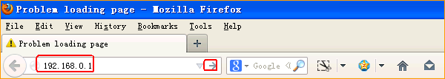
3.Input login username,password:admin, admin(default), to login, then click Advanced.
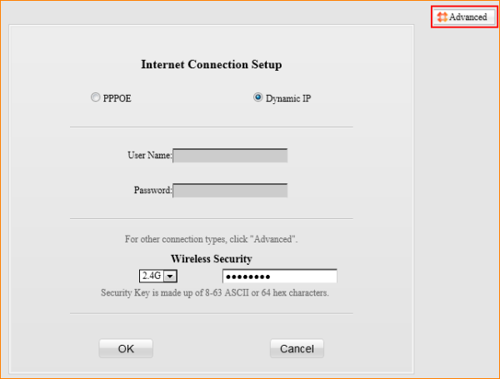
- Click Advanced, then click UPnP, tick Enable UPnP then click Save.
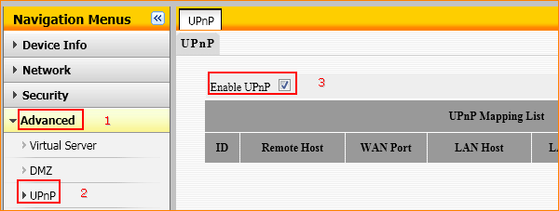
5.Reboot the router to active the settings.
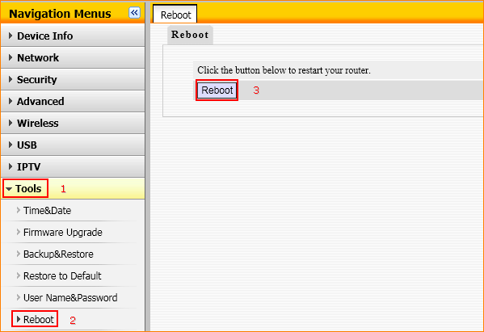
6. Restart your PS or Xbox.

